Remote access to course database - HeidiSQL installation on Aalto VDI

* Estimated reading time: 5 minutes

**Due to the school’s security requirement, we need to use Aalto VDI to access the course database server, which is provided by the school. Aalto VDI allows you to access university software, including MySQL, like you are using a university computer. By using VDI, you don’t need to install MySQL or HeidiSQL (already installed for you).**

1. Access “Aalto University Virtual Desktop Infrastructure - vdi.aalto.fi”. The official tutorial can be found here: <https://www.aalto.fi/en/services/vdiaaltofi-how-to-use-aalto-virtual-desktop-infrastructure>

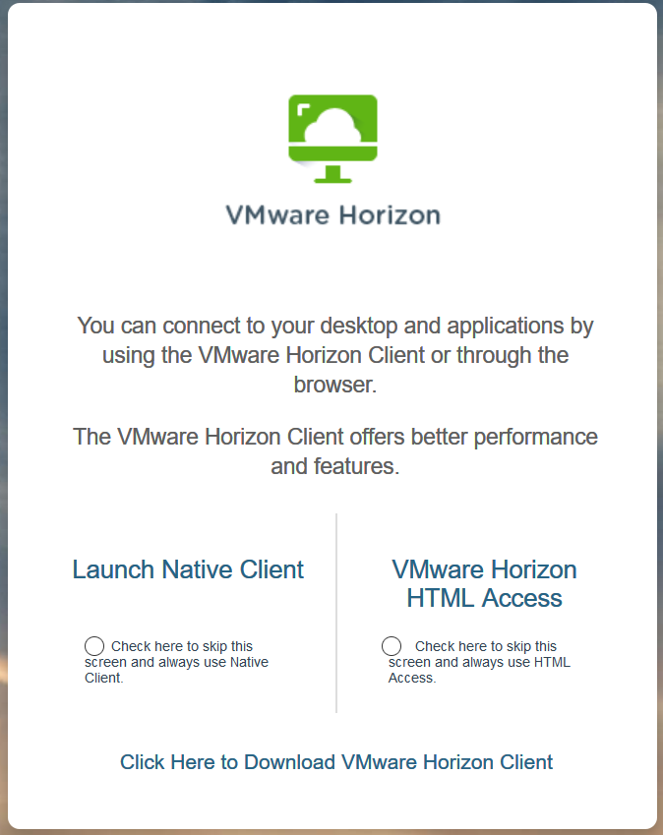

To access Aalto virtual workstation (or course database) via web browser, please:

1. Go to https://vdi.aalto.fi
2. Please click to **download VMware Horizon Client** and install the software

* It is **NOT** recommended to use HTML Access, because the user experience is not comparable to that of using the client.

1. After installing the Client, open the client and type the server name: **vdi.aalto.fi**
2. Type your Aalto username and password at the Client and click Login.
3. Choose **Windows 10**. It may take a while to load your university computer interface, just like turning on a new computer.

* Aalto VDI interface is similar to a remote desktop (a way to access super-computing powering via a cloud service). Thus, it would be good to get used to such an interface.

Please note that **quitting VDI** is different from shutting down a regular computer. You should choose ‘log off’ or ‘close’ to quit VDI.

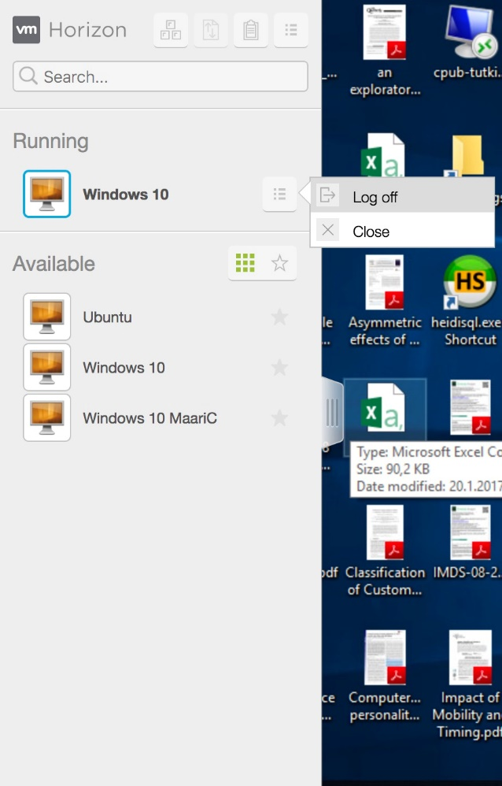

VDI will automatically lock down after a few minutes of no action. To activate the interface again, you must enter the “Ctrl+Alt+Delete” keys. For mac users, an equivalent of “Ctrl+Alt+Delete” could be one of follows options depending on your system:

;

;

+ backspace**, if there is no delete button on your keyboard

1. Start “HeidiSQL”: In the search function of the systems, search for “HeidiSQL” and you will find it.



1. After activating the “HeidiSQL”, you will see an interface like the one shown below.

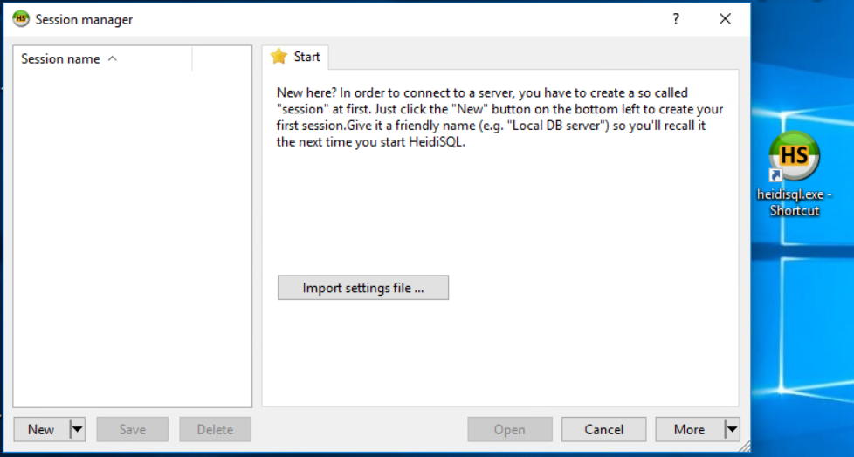

1. Importing SQL file to database

* Please watch a short video about how to import data at: https://mycourses.aalto.fi/course/view.php?id=36995&section=3